Four Poems by William Blake

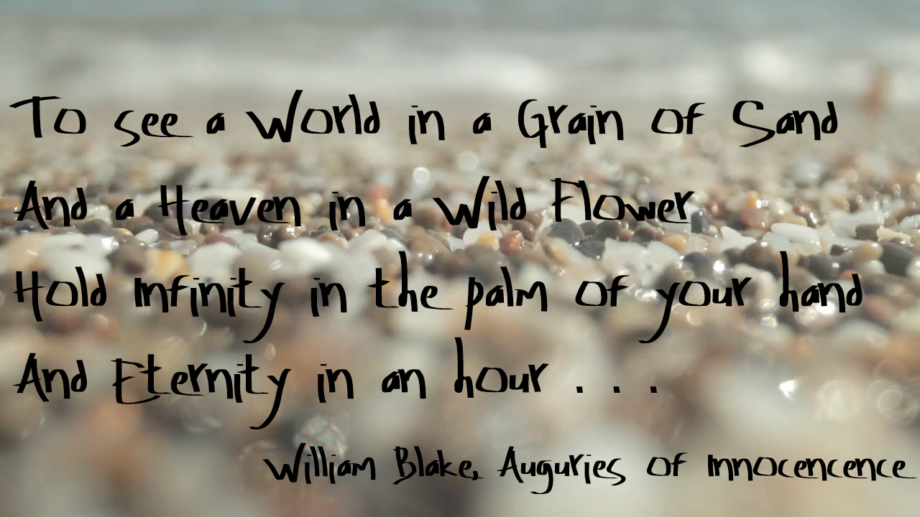

The Lamb

Little Lamb who made thee
Dost thou know who made thee
Gave thee life & bid thee feed.
By the stream & o'er the mead;
Gave thee clothing of delight,
Softest clothing wooly bright;
Gave thee such a tender voice,
Making all the vales rejoice!
Little Lamb who made thee
Dost thou know who made thee

Little Lamb I'll tell thee,
Little Lamb I'll tell thee!
He is called by thy name,
For he calls himself a Lamb:
He is meek & he is mild,
He became a little child:
I a child & thou a lamb,
We are called by his name.
Little Lamb God bless thee.
Little Lamb God bless thee.

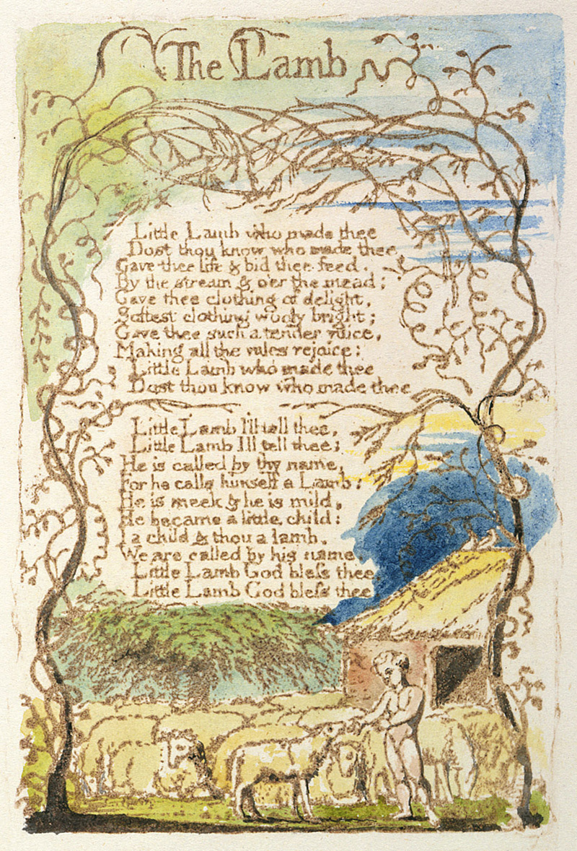
The Tyger

Tyger Tyger, burning bright,
In the forests of the night;
What immortal hand or eye,
Could frame thy fearful symmetry?

In what distant deeps or skies.
Burnt the fire of thine eyes?
On what wings dare he aspire?
What the hand, dare seize the fire?

And what shoulder, & what art,
Could twist the sinews of thy heart?
And when thy heart began to beat,
What dread hand? & what dread feet?

What the hammer? what the chain,
In what furnace was thy brain?
What the anvil? what dread grasp,
Dare its deadly terrors clasp!

When the stars threw down their spears
And water'd heaven with their tears:
Did he smile his work to see?
Did he who made the Lamb make thee?

Tyger Tyger burning bright,
In the forests of the night:
What immortal hand or eye,
Dare frame thy fearful symmetry?

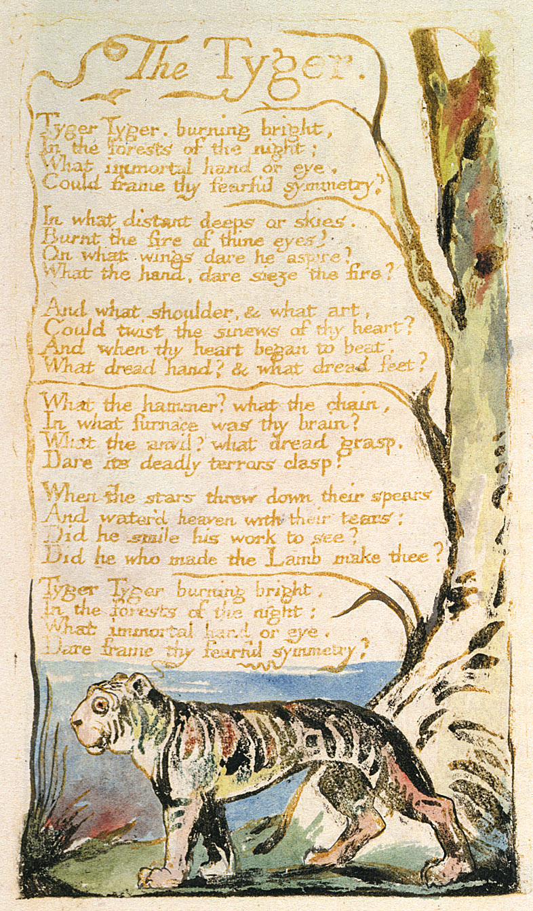
The Chimney Sweeper

When my mother died I was very young,
And my father sold me while yet my tongue
Could scarcely cry " 'weep! 'weep! 'weep! 'weep!"
So your chimneys I sweep & in soot I sleep.

There's little Tom Dacre, who cried when his head
That curled like a lamb's back, was shaved, so I said,
"Hush, Tom! never mind it, for when your head's bare,
You know that the soot cannot spoil your white hair."

And so he was quiet, & that very night,
As Tom was a-sleeping he had such a sight!
That thousands of sweepers, Dick, Joe, Ned, & Jack,
Were all of them locked up in coffins of black;

And by came an Angel who had a bright key,
And he opened the coffins & set them all free;
Then down a green plain, leaping, laughing they run,
And wash in a river and shine in the Sun.

Then naked & white, all their bags left behind,
They rise upon clouds, and sport in the wind.
And the Angel told Tom, if he'd be a good boy,
He'd have God for his father & never want joy.

And so Tom awoke; and we rose in the dark
And got with our bags & our brushes to work.
Though the morning was cold, Tom was happy & warm;
So if all do their duty, they need not fear harm.

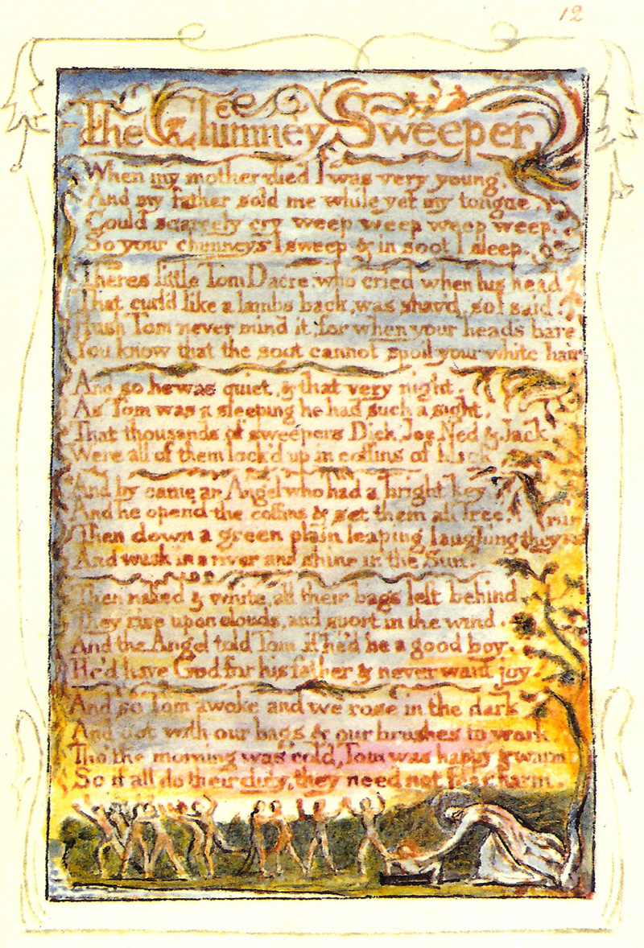
The Chimney Sweeper

A little black thing among the snow,
Crying "weep! 'weep!" in notes of woe!
"Where are thy father and mother? say?"
"They are both gone up to the church to pray.

Because I was happy upon the heath,
And smil'd among the winter's snow,
They clothed me in the clothes of death,
And taught me to sing the notes of woe.

And because I am happy and dance and sing,
They think they have done me no injury,
And are gone to praise God and his Priest and King,
Who make up a heaven of our misery."

