Two Poems by John Keats

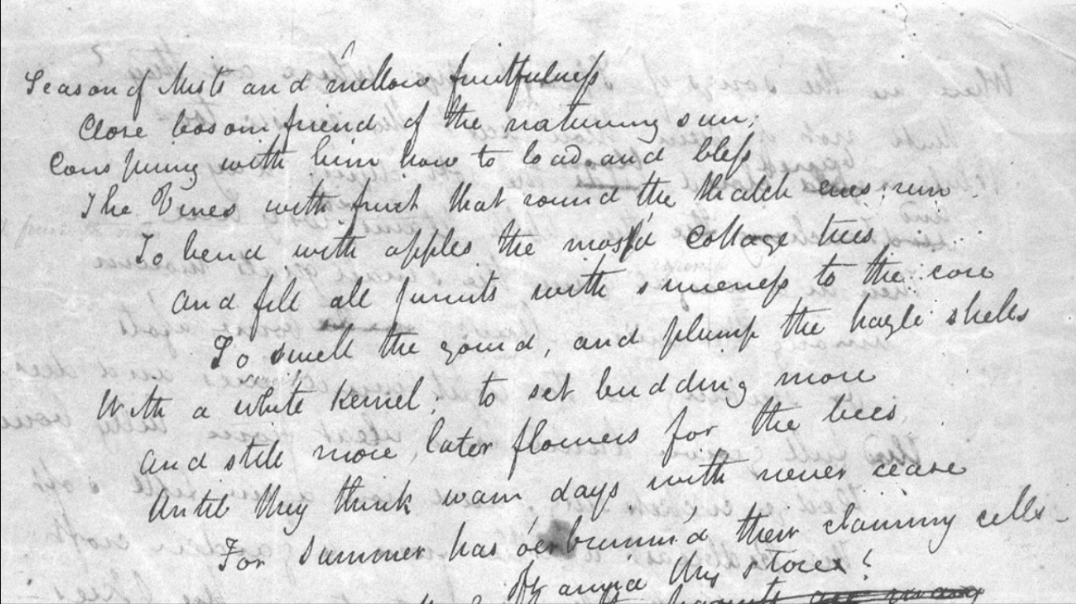

La belle dame sans merci

O WHAT can ail thee knight at arms,
Alone and palely loitering?
The sedge has withered from the lake
And no birds sing!

O what can ail thee knight at arms,
So haggard and so woe begone?
The squirrel’s granary is full
And the harvest’s done.

I see a lilly on thy brow
With anguish moist and fever dew,
And on thy cheeks a fading rose
Fast Withereth too—

I met a Lady in the Meads
Full beautiful, a faery’s child;
Her hair was long, her foot was light
And her eyes were wild—

I made a Garland for her head,
And bracelets too, and fragrant Zone
She look’d at me as she did love
And made sweet moan—

I set her on my pacing steed
And nothing else saw all day long,
For sidelong would she bend, and sing
A faery’s song—

She found me roots of relish sweet
And honey wild and manna dew,
And sure in language strange she said
I love thee true—

She took me to her elfin grot
And there she wept and sigh’d full sore,
And there I shut her wild wild eyes
With kisses four.

And there she lulled me asleep
And there I dream’d—Ah! Woe betide!
The latest dream I ever dreamt
On the cold hill side.

I saw pale kings and Princes too,
Pale warriors, death pale were they all;
They cried ‘La belle dame sans merci
Thee hath in thrall.’

I saw their starv’d lips in the gloam
With horrid warning gaped wide,
And I awoke and found me here
On the cold hill’s side.

And this is why I sojourn here
Alone and palely loitering;
Though the sedge is wither’d from the Lake
And no birds sing.

To Autumn

SEASON of mists and mellow fruitfulness!
Close bosom-friend of the maturing sun;
Conspiring with him how to load and bless
With fruit the vines that round the thatch-eaves run;
To bend with apples the moss’d cottage-trees,
And fill all fruit with ripeness to the core;
To swell the gourd, and plump the hazel shells
With a sweet kernel; to set budding more,
And still more, later flowers for the bees,
Until they think warm days will never cease,
For Summer has o’er-brimm’d their clammy cells.

Who hath not seen thee oft amid thy store?
Sometimes whoever seeks abroad may find
Thee sitting careless on a granary floor,
Thy hair soft-lifted by the winnowing wind;
Or on a half-reap’d furrow sound asleep,
Drowsed with the fumes of poppies, while thy hook
Spares the next swath and all its twinèd flowers;
And sometimes like a gleaner thou dost keep
Steady thy laden head across a brook;
Or by a cider-press, with patient look,
Thou watchest the last oozings, hours by hours.

Where are the songs of Spring? Ay, where are they?
Think not of them, thou hast thy music too,
While barrèd clouds bloom the soft-dying day,
And touch the stubble-plains with rosy hue;
Then in a wailful choir the small gnats mourn
Among the river sallows, borne aloft
Or sinking as the light wind lives or dies;
And full-grown lambs loud bleat from hilly bourn;
Hedge-crickets sing; and now with treble soft
The redbreast whistles from a garden-croft,
And gathering swallows twitter in the skies.

The beautiful woman without pity
Sedge - a grass-like tufted plant
Meads - meadows
Faery - fairy, one of the fae, a race of supernatural beings that precede humanity
Manna - a sugary extract from the sap of an Ash tree, but also associated with the biblical manna.
Grot - short for grotto, or cave
Betide - happen, or happen to
in thrall - under the power of someone or something
Gloam - twilight, or gloaming
thatch-eave - the bottom of a thatched cottage roof
winnowing - to separate grain from chaff. This involves using large hand-held fans to blow the mixture into the air so that the wind blows away the lighter chaff.
furrow - a long narrow trench made in the ground by a plow, and the row of crops that eventually grows there
hook - a scythe, an agricultural hand tool for mowing grass or reaping crops
gleaner - one who collects leftover crops from farmers' fields after they have been harvested
sallows - willow trees or shrubs, especially the pussy willow
redbreast - unlike in the US, where the robin is a herald of Spring, the English red-breasted robin is a winter bird
garden-croft - an enclosed garden or a small piece of land.

