Two poems by Walt Whitman

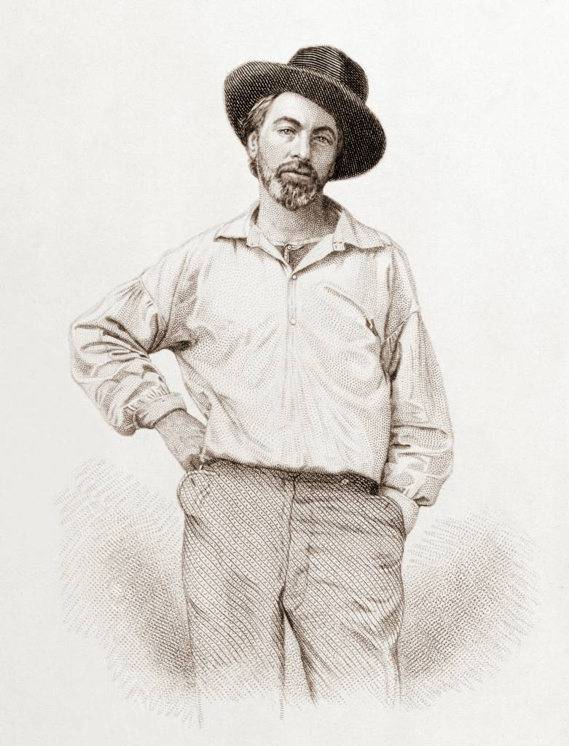
from “Song of Myself”

1
I celebrate myself, and sing myself,
And what I assume you shall assume,
For every atom belonging to me as good belongs to you.

I loafe and invite my soul,
I lean and loafe at my ease observing a spear of summer grass.

My tongue, every atom of my blood, form’d from this soil, this air,
Born here of parents born here from parents the same, and their parents the same,
I, now thirty-seven years old in perfect health begin,
Hoping to cease not till death.

Creeds and schools in abeyance,
Retiring back a while sufficed at what they are, but never forgotten,
I harbor for good or bad, I permit to speak at every hazard,
Nature without check with original energy.

7
Has any one supposed it lucky to be born?
I hasten to inform him or her it is just as lucky to die, and I know it.

I pass death with the dying and birth with the new-wash’d babe, and am not contain’d between my hat and boots,
And peruse manifold objects, no two alike and every one good,
The earth good and the stars good, and their adjuncts all good.

I am not an earth nor an adjunct of an earth,
I am the mate and companion of people, all just as immortal and fathomless as myself,
(They do not know how immortal, but I know.)

Every kind for itself and its own, for me mine male and female,
For me those that have been boys and that love women,
For me the man that is proud and feels how it stings to be slighted,
For me the sweet-heart and the old maid, for me mothers and the mothers of mothers,
For me lips that have smiled, eyes that have shed tears,
For me children and the begetters of children.

Undrape! you are not guilty to me, nor stale nor discarded,
I see through the broadcloth and gingham whether or no,
And am around, tenacious, acquisitive, tireless, and cannot be shaken away.
16
I am of old and young, of the foolish as much as the wise,
Regardless of others, ever regardful of others,
Maternal as well as paternal, a child as well as a man,
Stuff’d with the stuff that is coarse and stuff’d with the stuff that is fine,
One of the Nation of many nations, the smallest the same and the largest the same,
A Southerner soon as a Northerner, a planter nonchalant and hospitable down by the Oconee I live,
A Yankee bound my own way ready for trade, my joints the limberest joints on earth and the sternest joints on earth,
A Kentuckian walking the vale of the Elkhorn in my deer-skin leggings, a Louisianian or Georgian,
A boatman over lakes or bays or along coasts, a Hoosier, Badger, Buckeye;
At home on Kanadian snow-shoes or up in the bush, or with fishermen off Newfoundland,
At home in the fleet of ice-boats, sailing with the rest and tacking,
At home on the hills of Vermont or in the woods of Maine, or the Texan ranch,
Comrade of Californians, comrade of free North-Westerners, (loving their big proportions,)
Comrade of raftsmen and coalmen, comrade of all who shake hands and welcome to drink and meat,
A learner with the simplest, a teacher of the thoughtfullest,
A novice beginning yet experient of myriads of seasons,
Of every hue and caste am I, of every rank and religion,
A farmer, mechanic, artist, gentleman, sailor, quaker,
Prisoner, fancy-man, rowdy, lawyer, physician, priest.

I resist any thing better than my own diversity,
Breathe the air but leave plenty after me,
And am not stuck up, and am in my place.

(The moth and the fish-eggs are in their place,
The bright suns I see and the dark suns I cannot see are in their place,
The palpable is in its place and the impalpable is in its place.)

24
Walt Whitman, a kosmos, of Manhattan the son,
Turbulent, fleshy, sensual, eating, drinking and breeding,
No sentimentalist, no stander above men and women or apart from them,
No more modest than immodest.

Unscrew the locks from the doors!
Unscrew the doors themselves from their jambs!

Whoever degrades another degrades me,
And whatever is done or said returns at last to me.

Through me the afflatus surging and surging, through me the current and index.

I speak the pass-word primeval, I give the sign of democracy,
By God! I will accept nothing which all cannot have their
counterpart of on the same terms.
Through me many long dumb voices,
Voices of the interminable generations of prisoners and slaves,
Voices of the diseas’d and despairing and of thieves and dwarfs,
Voices of cycles of preparation and accretion,
And of the threads that connect the stars, and of wombs and of the father-stuff,
And of the rights of them the others are down upon,
Of the deform’d, trivial, flat, foolish, despised,
Fog in the air, beetles rolling balls of dung.

Through me forbidden voices,
Voices of sexes and lusts, voices veil’d and I remove the veil,
Voices indecent by me clarified and transfigur’d.

I do not press my fingers across my mouth,
I keep as delicate around the bowels as around the head and heart,
Copulation is no more rank to me than death is.

I believe in the flesh and the appetites,
Seeing, hearing, feeling, are miracles, and each part and tag of me is a miracle.

Divine am I inside and out, and I make holy whatever I touch or am touch’d from,
The scent of these arm-pits aroma finer than prayer,
This head more than churches, bibles, and all the creeds.

If I worship one thing more than another it shall be the spread of my own body, or any part of it,
Translucent mould of me it shall be you!
Shaded ledges and rests it shall be you!
Firm masculine colter it shall be you!
Whatever goes to the tilth of me it shall be you!
You my rich blood! your milky stream pale strippings of my life!
Breast that presses against other breasts it shall be you!
My brain it shall be your occult convolutions!
Root of wash’d sweet-flag! timorous pond-snipe! nest of guarded
duplicate eggs! it shall be you!
Mix’d tussled hay of head, beard, brawn, it shall be you!
Trickling sap of maple, fibre of manly wheat, it shall be you!
Sun so generous it shall be you!
Vapors lighting and shading my face it shall be you!
You sweaty brooks and dews it shall be you!
Winds whose soft-tickling genitals rub against me it shall be you!
Broad muscular fields, branches of live oak, loving lounger in my winding paths, it shall be you!
Hands I have taken, face I have kiss’d, mortal I have ever touch’d, it shall be you.

I dote on myself, there is that lot of me and all so luscious,
Each moment and whatever happens thrills me with joy,
I cannot tell how my ankles bend, nor whence the cause of my faintest wish,
Nor the cause of the friendship I emit, nor the cause of the friendship I take again.

That I walk up my stoop, I pause to consider if it really be,
A morning-glory at my window satisfies me more than the metaphysics of books.

To behold the day-break!
The little light fades the immense and diaphanous shadows,
The air tastes good to my palate.

Hefts of the moving world at innocent gambols silently rising
freshly exuding,
Scooting obliquely high and low.

Something I cannot see puts upward libidinous prongs,
Seas of bright juice suffuse heaven.

The earth by the sky staid with, the daily close of their junction,
The heav’d challenge from the east that moment over my head,
The mocking taunt, See then whether you shall be master!

46
I know I have the best of time and space, and was never measured and never will be measured.

I tramp a perpetual journey, (come listen all!)
My signs are a rain-proof coat, good shoes, and a staff cut from the woods,
No friend of mine takes his ease in my chair,
I have no chair, no church, no philosophy,
I lead no man to a dinner-table, library, exchange,
But each man and each woman of you I lead upon a knoll,
My left hand hooking you round the waist,
My right hand pointing to landscapes of continents and the public road.

Not I, not any one else can travel that road for you,
You must travel it for yourself.

It is not far, it is within reach,
Perhaps you have been on it since you were born and did not know,
Perhaps it is everywhere on water and on land.

Shoulder your duds dear son, and I will mine, and let us hasten forth,
Wonderful cities and free nations we shall fetch as we go.

If you tire, give me both burdens, and rest the chuff of your hand on my hip,
And in due time you shall repay the same service to me,
For after we start we never lie by again.

This day before dawn I ascended a hill and look’d at the crowded heaven,
And I said to my spirit When we become the enfolders of those orbs,
and the pleasure and knowledge of every thing in them, shall we be fill’d and satisfied then?
And my spirit said No, we but level that lift to pass and continue beyond.

You are also asking me questions and I hear you,
I answer that I cannot answer, you must find out for yourself.

Sit a while dear son,
Here are biscuits to eat and here is milk to drink,
But as soon as you sleep and renew yourself in sweet clothes, I kiss
you with a good-by kiss and open the gate for your egress hence.

Long enough have you dream’d contemptible dreams,
Now I wash the gum from your eyes,
You must habit yourself to the dazzle of the light and of every moment of your life.

Long have you timidly waded holding a plank by the shore,
Now I will you to be a bold swimmer,
To jump off in the midst of the sea, rise again, nod to me, shout, and laughingly dash with your hair.

51
The past and present wilt - I have fill’d them, emptied them.
And proceed to fill my next fold of the future.

Listener up there! what have you to confide to me?
Look in my face while I snuff the sidle of evening,
(Talk honestly, no one else hears you, and I stay only a minute longer.)

Do I contradict myself?
Very well then I contradict myself,
(I am large, I contain multitudes.)

I concentrate toward them that are nigh, I wait on the door-slab.

Who has done his day’s work? who will soonest be through with his supper?
Who wishes to walk with me?

Will you speak before I am gone? will you prove already too late?

52
The spotted hawk swoops by and accuses me, he complains of my gab and my loitering.

I too am not a bit tamed, I too am untranslatable,
I sound my barbaric yaws over the roofs of the world.

The last scud of day holds back for me,
It flings my likeness after the rest and true as any on the shadow’d wilds,
It coaxes me to the vapor and the dusk.

I depart as air, I shake my white locks at the runaway sun,
I effuse my flesh in eddies, and drift it in lacy jags.

I bequeath myself to the dirt to grow from the grass I love,
If you want me again look for me under your boot-soles.

You will hardly know who I am or what I mean,
But I shall be good health to you nevertheless,
And filter and fibre your blood.

Failing to fetch me at first keep encouraged,
Missing me one place search another,
I stop somewhere waiting for you.

Out of the Cradle Endlessly Rocking

Out of the cradle endlessly rocking,
Out of the mocking-bird’s throat, the musical shuttle,
Out of the Ninth-month midnight,
Over the sterile sands, and the fields beyond, where the child, leaving his bed, wander’d alone, bare-headed, barefoot,
Down from the shower’d halo,
Up from the mystic play of shadows, twining and twisting as if they were alive,
Out from the patches of briers and blackberries,
From the memories of the bird that chanted to me,
From your memories, sad brother — from the fitful risings and fallings I heard,
From under that yellow half-moon, late-risen, and swollen as if with tears,
From those beginning notes of sickness and love, there in the transparent mist,
From the thousand responses of my heart, never to cease,
From the myriad thence-arous’d words,
From the word stronger and more delicious than any,
From such, as now they start, the scene revisiting,
As a flock, twittering, rising, or overhead passing,
Borne hither — ere all eludes me, hurriedly,
A man — yet by these tears a little boy again,
Throwing myself on the sand, confronting the waves,
I, chanter of pains and joys, uniter of here and hereafter,
Taking all hints to use them — but swiftly leaping beyond them,
A reminiscence sing.

Once, Paumanok,
When the snows had melted — when the lilac-scent was in the air, and the Fifth-month grass was growing,
Up this sea-shore, in some briers,
Two guests from Alabama — two together,
And their nest, and four light-green eggs, spotted with brown,
And every day the he-bird, to and fro, near at hand,
And every day the she-bird, crouch’d on her nest, silent, with bright eyes,
And every day I, a curious boy, never too close, never disturbing them,
Cautiously peering, absorbing, translating.

Shine! shine! shine!
Pour down your warmth, great Sun!
While we bask — we two together.

Two together!
Winds blow South, or winds blow North,
Day come white, or night come black,
Home, or rivers and mountains from home,
Singing all time, minding no time,
While we two keep together.

Till of a sudden,
May-be kill’d, unknown to her mate,
One forenoon the she-bird crouch’d not on the nest,
Nor return’d that afternoon, nor the next,
Nor ever appear’d again.

And thenceforward, all summer, in the sound of the sea,
And at night, under the full of the moon, in calmer weather,
Over the hoarse surging of the sea,
Or flitting from brier to brier by day,
I saw, I heard at intervals, the remaining one, the he-bird,
The solitary guest from Alabama.

Blow! blow! blow!
Blow up, sea-winds, along Paumanok’s shore!
I wait and I wait, till you blow my mate to me.

Yes, when the stars glisten’d,
All night long, on the prong of a moss-scallop’d stake,
Down, almost amid the slapping waves,
Sat the lone singer, wonderful, causing tears.

He call’d on his mate;
He pour’d forth the meanings which I, of all men, know.

Yes, my brother, I know;
The rest might not — but I have treasur’d every note;
For once, and more than once, dimly, down to the beach gliding,
Silent, avoiding the moonbeams, blending myself with the shadows,
Recalling now the obscure shapes, the echoes, the sounds and sights after their sorts,
The white arms out in the breakers tirelessly tossing,
I, with bare feet, a child, the wind wafting my hair,
Listen’d long and long.

Listen’d, to keep, to sing — now translating the notes,
Following you, my brother.

Soothe! soothe! soothe!
Close on its wave soothes the wave behind,
And again another behind, embracing and lapping, every one close,
But my love soothes not me, not me.

Low hangs the moon — it rose late;
O it is lagging — O I think it is heavy with love, with love.

O madly the sea pushes, pushes upon the land,
With love — with love.

O night! do I not see my love fluttering out there among the breakers?
What is that little black thing I see there in the white?

Loud! loud! loud!
Loud I call to you, my love!

High and clear I shoot my voice over the waves;
Surely you must know who is here, is here;
You must know who I am, my love.

Low-hanging moon!
What is that dusky spot in your brown yellow?
O it is the shape, the shape of my mate!
O moon, do not keep her from me any longer.

Land! land! O land!
Whichever way I turn, O I think you could give me my mate back again, if you only would;
For I am almost sure I see her dimly whichever way I look.

O rising stars!
Perhaps the one I want so much will rise, will rise with some of you.

O throat! O trembling throat!
Sound clearer through the atmosphere!
Pierce the woods, the earth;
Somewhere listening to catch you, must be the one I want.

Shake out, carols!
Solitary here — the night’s carols!
Carols of lonesome love! Death’s carols!
Carols under that lagging, yellow, waning moon!
O, under that moon, where she droops almost down into the sea!
O reckless, despairing carols.

But soft! sink low;
Soft! let me just murmur;
And do you wait a moment, you husky-noised sea;
For somewhere I believe I heard my mate responding to me,
So faint — I must be still, be still to listen;
But not altogether still, for then she might not come immediately to me.

Hither, my love!
Here I am! Here!
With this just-sustain’d note I announce myself to you;
This gentle call is for you, my love, for you.

Do not be decoy’d elsewhere!
That is the whistle of the wind — it is not my voice;
That is the fluttering, the fluttering of the spray;
Those are the shadows of leaves.

O darkness! O in vain!
O I am very sick and sorrowful.

O brown halo in the sky, near the moon, drooping upon the sea!
O troubled reflection in the sea!
O throat! O throbbing heart!
O all — and I singing uselessly, uselessly all the night.

Yet I murmur, murmur on!
O murmurs — you yourselves make me continue to sing, I know not why.

O past! O life! O songs of joy!
In the air — in the woods — over fields;
Loved! loved! loved! loved! loved!
But my love no more, no more with me!
We two together no more.

The aria sinking;
All else continuing — the stars shining,
The winds blowing — the notes of the bird continuous echoing,
With angry moans the fierce old mother incessantly moaning,
On the sands of Paumanok’s shore, gray and rustling;
The yellow half-moon enlarged, sagging down, drooping, the face of the sea almost touching;
The boy extatic — with his bare feet the waves, with his hair the atmosphere dallying,
The love in the heart long pent, now loose, now at last tumultuously bursting,
The aria’s meaning, the ears, the Soul, swiftly depositing,
The strange tears down the cheeks coursing,
The colloquy there — the trio — each uttering,
The undertone — the savage old mother, incessantly crying,
To the boy’s Soul’s questions sullenly timing — some drown’d secret hissing,
To the outsetting bard of love.

Demon or bird! (said the boy’s soul,)
Is it indeed toward your mate you sing? or is it mostly to me?
For I, that was a child, my tongue’s use sleeping,
Now I have heard you,
Now in a moment I know what I am for — I awake,
And already a thousand singers — a thousand songs, clearer, louder and more sorrowful than yours,
A thousand warbling echoes have started to life within me,
Never to die.

O you singer, solitary, singing by yourself — projecting me;
O solitary me, listening — nevermore shall I cease perpetuating you;
Never more shall I escape, never more the reverberations,
Never more the cries of unsatisfied love be absent from me,
Never again leave me to be the peaceful child I was before what there, in the night,
By the sea, under the yellow and sagging moon,
The messenger there arous’d — the fire, the sweet hell within,
The unknown want, the destiny of me.

O give me the clew! (it lurks in the night here somewhere;)
O if I am to have so much, let me have more!
O a word! O what is my destination? (I fear it is henceforth chaos;)
O how joys, dreads, convolutions, human shapes, and all shapes, spring as from graves around me!
O phantoms! you cover all the land and all the sea!
O I cannot see in the dimness whether you smile or frown upon me;
O vapor, a look, a word! O well-beloved!
O you dear women’s and men’s phantoms!

A word then, (for I will conquer it,)
The word final, superior to all,
Subtle, sent up — what is it? — I listen;
Are you whispering it, and have been all the time, you sea-waves?
Is that it from your liquid rims and wet sands?

Whereto answering, the sea,
Delaying not, hurrying not,
Whisper’d me through the night, and very plainly before day-break,
Lisp’d to me the low and delicious word DEATH;
And again Death — ever Death, Death, Death,
Hissing melodious, neither like the bird, nor like my arous’d child’s heart,
But edging near, as privately for me, rustling at my feet,
Creeping thence steadily up to my ears, and laving me softly all over,
Death, Death, Death, Death, Death.

Which I do not forget,
But fuse the song of my dusky demon and brother,
That he sang to me in the moonlight on Paumanok’s gray beach,
With the thousand responsive songs, at random,
My own songs, awaked from that hour;
And with them the key, the word up from the waves,
The word of the sweetest song, and all songs,
That strong and delicious word which, creeping to my feet,
The sea whisper’d me.

