Four Poems by William Butler Yeats

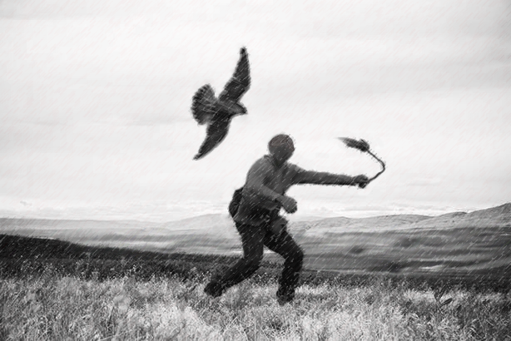

When You Are Old

When you are old and grey and full of sleep,
And nodding by the fire, take down this book,
And slowly read, and dream of the soft look
Your eyes had once, and of their shadows deep;

How many loved your moments of glad grace,
And loved your beauty with love false or true,
But one man loved the pilgrim soul in you,
And loved the sorrows of your changing face;

And bending down beside the glowing bars,
Murmur, a little sadly, how Love fled
And paced upon the mountains overhead
And hid his face amid a crowd of stars.

Easter, 1916

I have met them at close of day
Coming with vivid faces
From counter or desk among grey
Eighteenth-century houses.
I have passed with a nod of the head
Or polite meaningless words,
Or have lingered awhile and said
Polite meaningless words,
And thought before I had done
Of a mocking tale or a gibe
To please a companion
Around the fire at the club,
Being certain that they and I
But lived where motley is worn:
All changed, changed utterly:
A terrible beauty is born.

That woman's days were spent
In ignorant good-will,
Her nights in argument
Until her voice grew shrill.
What voice more sweet than hers
When, young and beautiful,
She rode to harriers?
This man had kept a school
And rode our wingèd horse;
This other his helper and friend
Was coming into his force;
He might have won fame in the end,
So sensitive his nature seemed,
So daring and sweet his thought.
This other man I had dreamed
A drunken, vainglorious lout.
He had done most bitter wrong
To some who are near my heart,
Yet I number him in the song;
He, too, has resigned his part
In the casual comedy;
He, too, has been changed in his turn,
Transformed utterly:
A terrible beauty is born.

Hearts with one purpose alone
Through summer and winter seem
Enchanted to a stone
To trouble the living stream.
The horse that comes from the road,
The rider, the birds that range
From cloud to tumbling cloud,
Minute by minute they change;
A shadow of cloud on the stream
Changes minute by minute;
A horse-hoof slides on the brim,
And a horse plashes within it;
The long-legged moor-hens dive,
And hens to moor-cocks call;
Minute by minute they live:
The stone's in the midst of all.

Too long a sacrifice
Can make a stone of the heart.
O when may it suffice?
That is Heaven's part, our part
To murmur name upon name,
As a mother names her child
When sleep at last has come
On limbs that had run wild.
What is it but nightfall?
No, no, not night but death;
Was it needless death after all?
For England may keep faith
For all that is done and said.
We know their dream; enough
To know they dreamed and are dead;
And what if excess of love
Bewildered them till they died?
I write it out in a verse—
MacDonagh and MacBride
And Connolly and Pearse
Now and in time to be,
Wherever green is worn,
Are changed, changed utterly:
A terrible beauty is born.

September 25, 1916
The Second Coming

Turning and turning in the widening gyre
The falcon cannot hear the falconer;
Things fall apart; the centre cannot hold;
Mere anarchy is loosed upon the world,
The blood-dimmed tide is loosed, and everywhere
The ceremony of innocence is drowned;
The best lack all conviction, while the worst
Are full of passionate intensity.

Surely some revelation is at hand;
Surely the Second Coming is at hand.
The Second Coming! Hardly are those words out
When a vast image out of Spiritus Mundi
Troubles my sight: somewhere in sands of the desert
A shape with lion body and the head of a man,
A gaze blank and pitiless as the sun,
Is moving its slow thighs, while all about it
Reel shadows of the indignant desert birds.
The darkness drops again; but now I know
That twenty centuries of stony sleep
Were vexed to nightmare by a rocking cradle,
And what rough beast, its hour come round at last,
Slouches towards Bethlehem to be born?

Leda and the Swan

A sudden blow: the great wings beating still
Above the staggering girl, her thighs caressed
By the dark webs, her nape caught in his bill,
He holds her helpless breast upon his breast.

How can those terrified vague fingers push
The feathered glory from her loosening thighs?
And how can body, laid in that white rush,
But feel the strange heart beating where it lies?

A shudder in the loins engenders there
The broken wall, the burning roof and tower
And Agamemnon dead.
Being so caught up,
So mastered by the brute blood of the air,
Did she put on his knowledge with his power
Before the indifferent beak could let her drop?

The Easter Rising began on Easter Monday, April 24, 1916, and lasted for six days. Yeats manipulates the number of stanzas and the number of lines per stanza to numerologically inscribe that date in the poem: number of stanzas – 4; number of lines in stanzas 1 and 3 – 16; number of lines in stanzas 2 and 4: - 24. Combining those numbers (16 + 24) creates another significant number, 40, usually associated with a trial or testing, as in Noah’s flood, Israel’s wandering in the wilderness, Moses’ stay on Mt. Sinai, Jesus’ temptation in the wilderness, and the length of Lent, the period of penitence before Easter Lent.
Motley - the patchwork of colors that would traditionally be worn by a jester
The Countess Constance Markievicz, who was one of the leaders of the Easter Uprising. She was sentenced to death, but got the sentence reduced to life in prison. Although she was a member of the Anglo-Irish Protestant gentry, she gave up that life to fight for the rights of the disenfranchised and the poor. She and Yeats met decades before this, and were good friends, although Yeats was appalled at her decision to work for the good of the lower classes.
To ride to harriers is to hunt hares with a pack of dogs while on horseback. It is certainly an upper-class activity.
Padraic Pearse, another leader of the Easter Uprising. He founded a boy’s school in Dublin and was a poet. The winged horse is the mythological Pegasus, Everywhere the horse struck its hoof on the earth, an inspiring spring burst forth. The most important of these was on Mount Helicon, which was the home of the nine Muses. Pegasus was sometimes considered the horse of the Muses, and thus he was connected with poetic inspiration.
Thomas MacDonagh, a poet and dramatist who was also involved with the Uprising. Yeats seems to regret his death the most, because he was "coming into his force," or just beginning to become a good writer, when he was executed for his part in the Uprising.
Major John MacBride, a man who was once married to Maud Gonne, the woman Yeats loved throughout his life. Yeats’ description of MacBride—although accurate— deeply offended Maud, who believed that the poem was not worthy of her husband.
James Connolly, one of the founders of the Irish Citizen Army, who defended workers and strikers and whose goal was the establishment of an independent and socialist Irish nation. During the Easter Rising, Connolly was Commandant of the Dublin Brigade. As the Dublin Brigade had the most substantial role in the rising, he was de facto commander-in-chief. Connolly's leadership in the Easter rising was considered formidable.
Literally, “the Spirit of the World.” For Yeats, this was a collection of communal memories that exists throughout human history. It is something akin to Jung’s idea of the Collective Unconscious.

