Реквием 1935-1940 (“Requiem”)

Anna Akhmatova

Translated by Judith Hemschemeyer

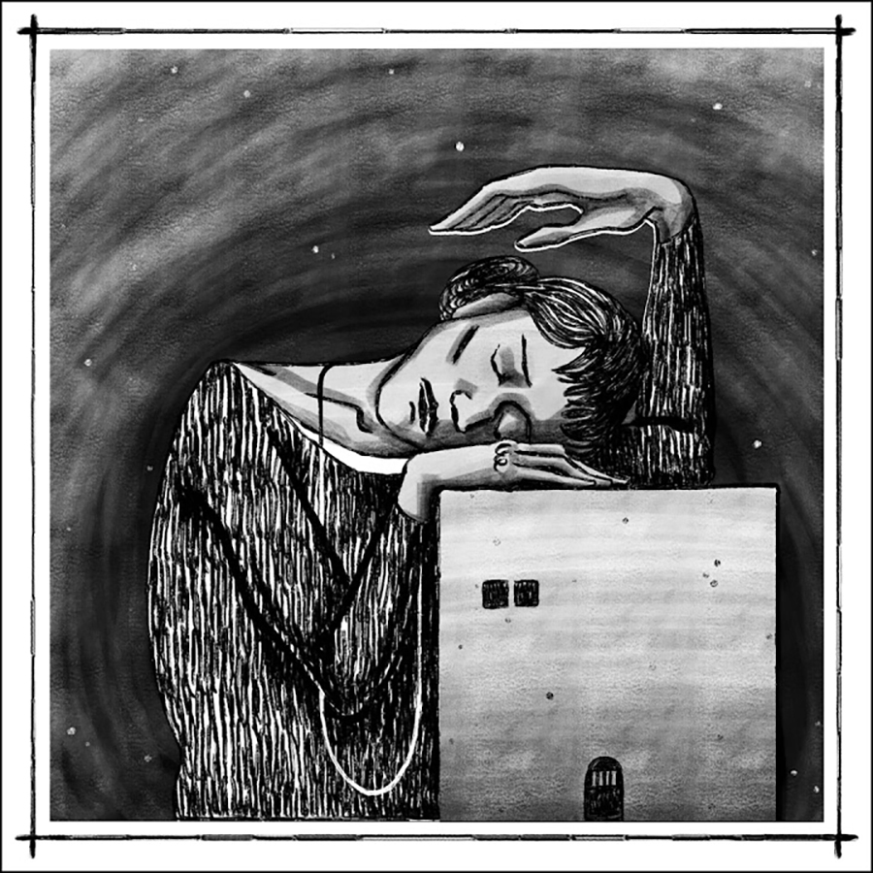

No, not under the vault of alien skies,
And not under the shelter of alien wings—
I was with my people then,
There, where my people, unfortunately, were.

1961

Instead of a Preface

In the terrible years of the Yezhov terror, I spent seventeen months in the prison lines of Leningrad. Once, someone “recognized” me. Then a woman with bluish lips standing behind me, who, of course, had never heard me called by name before, woke up from the stupor to which everyone had succumbed and whispered in my ear (everyone spoke in whispers there):
“Can you describe this?”
And I answered: “Yes, I can.”
Then something that looked like a smile passed over what had once been her face.

April 1, 1957, Leningrad

Dedication

Mountains bow down to this grief,
Mighty rivers cease to flow,
But the prison gates hold firm,
And behind them are the “prisoners’ burrows”
And mortal woe.
For someone a fresh breeze blows,
For someone the sunset luxuriates—
We wouldn’t know, we are those who everywhere
Hear only the rasp of the hateful key
And the soldiers’ heavy tread.
We rose as if for an early service,
Trudged through the savaged capital
And met there, more lifeless than the dead;
The sun is lower and the Neva mistier,
But hope keeps singing from afar.
The verdict… And her tears gush forth,
Already she is cut off from the rest,
As if they painfully wrenched life from her heart,
As if they brutally knocked her flat,
But she goes on… Staggering… Alone…
Where now are my chance friends
Of those two diabolical years?
What do they imagine is in Siberia’s storms,
What appears to them dimly in the circle of the moon?
I am sending my farewell greeting to them.

March 1940

Prologue

That was when the ones who smiled
Were the dead, glad to be at rest.
And like a useless appendage, Leningrad
Swung from its prisons.
And when, senseless from torment,
Regiments of convicts marched,
And the short songs of farewell
Were sung by locomotive whistles.
The stars of death stood above us
And innocent Russia writhed
Under bloody boots
And under the tires of the Black Marias.

I

They led you away at dawn,
I followed you, like a mourner,
In the dark front room the children were crying,
By the icon shelf the candle was dying.
On your lips was the icon’s chill.
The deathly sweat on your brow… Unforgettable!—
I will be like the wives of the Streltsy,
Howling under the Kremlin towers.

1935

II

Quietly flows the quiet Don,
Yellow moon slips into a home.

He slips in with cap askew,
He sees a shadow, yellow moon.

This woman is ill,
This woman is alone,

Husband in the grave, son in prison,
Say a prayer for me.

III

No, it is not I, it is somebody else who is suffering.
I would not have been able to bear what
happened, Let them shroud it in black,
And let them carry off the lanterns…
Night.

1940

IV

You should have been shown, you mocker,
Minion of all your friends,
Gay little sinner of Tsarskoye Selo,
What would happen in your life—
How three-hundredth in line, with a parcel,
You would stand by the Kresty prison,
Your tempestuous tears
Burning through the New Year’s ice.
Over there the prison poplar bends,
And there’s no sound—and over there how many
Innocent lives are ending now…

V

For seventeen months I’ve been crying out,
Calling you home.
I flung myself at the hangman’s feet,
You are my son and my horror.
Everything is confused forever,
And it’s not clear to me
Who is a beast now, who is a man,
And how long before the execution.
And there are only dusty flowers,
And the chinking of the censer, and tracks
From somewhere to nowhere.
And staring me straight in the eyes,
And threatening impending death,
Is an enormous star.

1939

VI

The light weeks will take flight,
I won’t comprehend what happened.
Just as the white nights
Stared at you, dear son, in prison,
So they are staring again,
With the burning eyes of a hawk,
Thinking about your lofty cross,
And about death.

1939

VII

The Sentence

And the stone word fell
On my still-living breast.
Never mind, I was ready.
I will manage somehow.

Today I have so much to do:
I must kill memory once and for all,
I must turn my soul to stone,
I must learn to live again—

Unless… Summer’s ardent rustling
Is like a festival outside my window.
For a long time I’ve foreseen this
Brilliant day, deserted house.

June 22, 1939, Fountain House

VIII

To Death

You will come in any case—so why not now?
I am waiting for you—I can’t stand much more.
I’ve put out the light and opened the door
For you, so simple and miraculous.
So come in any form you please,
Burst in as a gas shell
Or, like a gangster, steal in with a length of pipe,
Or poison me with typhus fumes.
Or be that fairy tale you’ve dreamed up,
So sickeningly familiar to everyone—
In which I glimpse the top of a pale blue cap
And the house attendant white with fear.
Now it doesn’t matter anymore. The Yenisey swirls,
The North Star shines.
And the final horror dims
The blue luster of beloved eyes.

August 19, 1939, Fountain House

IX

Now madness half shadows
My soul with its wing,
And makes it drunk with fiery wine
And beckons toward the black ravine.

And I’ve finally realized
That I must give in,
Overhearing myself
Raving as if it were somebody else.

And it does not allow me to take
Anything of mine with me
(No matter how I plead with it,
No matter how I supplicate):

Not the terrible eyes of my son—
Suffering turned to stone,
Not the day of the terror,
Not the hour I met with him in prison,

Not the sweet coolness of his hands,
Not the trembling shadow of the lindens,
Not the far-off; fragile sound—
Of the final words of consolation.

May 4, 1940, Fountain House

X

Crucifixion

“Do not weep for Me, Mother,
I am in the grave.”

1
A choir of angels sang the praises of that momentous hour,
And the heavens dissolved in fire.
To his Father He said: “Why hast Thou forsaken me!”
And to his Mother: “Oh, do not weep for Me . . .”

1940, Fountain House

2
Mary Magdalene beat her breast and sobbed,
The beloved disciple turned to stone,
But where the silent Mother stood, there
No one glanced and no one would have dared.

1943, Tashkent

Epilogue I

I learned how faces fall,
How terror darts from under eyelids,
How suffering traces lines
Of stiff cuneiform on cheeks,
How locks of ashen-blonde or black
Turn silver suddenly,
Smiles fade on submissive lips
And fear trembles in a dry laugh.
And I pray not for myself alone,
But for all those who stood there with me
In cruel cold, and in July’s heat,
At that blind, red wall.

Epilogue II

Once more the day of remembrance draws near.
I see, I hear, feel you:

The one they almost had to drag at the end,
And the one who tramps her native land no more,

And the one who, tossing her beautiful head,
Said: “Coming here’s like coming home.”

I’d like to name them all by name,
But the list has been confiscated and is nowhere to be found.

I have woven a wide mantle for them
From their meager, overheard words.

I will remember them always and everywhere,
I will never forget them no matter what comes.

And if they gag my exhausted mouth
Through which a hundred million scream,

Then may the people remember me
On the eve of my remembrance day.

And if ever in this country
They decide to erect a monument to me,

I consent to that honor
Under these conditions—that it stand

Neither by the sea, where I was born:
My last tie with the sea is broken,

Nor in the tsar’s garden near the cherished pine stump,
Where an inconsolable shade looks for me,

But here, where I stood for three hundred hours,
And where they never unbolted the doors for me.

This, lest in blissful death
I forget the rumbling of the Black Marias,

Forget how that detested door slammed shut
And an old woman howled like a wounded animal.

And may the melting snow stream like tears
From my motionless lids of bronze,

And a prison dove coo in the distance,
And the ships of the Neva sail calmly on.

March 1940

A campaign of political repression in the Soviet Union, spanning from 1936 to 1938. It was a large-scale purge of the Communist Party and government officials, repression of peasants and the Red Army leadership, widespread police surveillance, suspicion of “saboteurs,” “counter-revolutionaries,” imprisonment, and arbitrary executions. It is named after Nikolai Yezhov, the head of the Soviet secret police, the NKVD, who was himself later killed in the purge. Mobile gas vans were used to execute people without trial. Historians estimate that in 1937-38 between 950,000 and 1,200,000 people were killed, either by execution or in labor camps. During Stalin’s reign, at least 26,000,000 Russians were sent to gulag camps. Estimates of deaths in the camps vary, from a low of 1,500,000 up to 20.000,000.
Lev Gumilev, Akhmatova’s son, was held in the Kresty Prison (also known as the Prison of the Crosses) in Leningrad.
Thatched-roof earthen dugouts, essentially foxholes dug into the ground, where prisoners slept, usually two or three deep.
River that flows through the city of Saint Petersburg (Leningrad).
A large geographic region in Russia, where the majority of gulag camps were situated. It was known primarily for its long, harsh winters, with a January average of −25 °C (−13 °F).
A slang term for the police vans used to transport prisoners
Akhmatova’s third husband, Nikolay Punin who, along with other close confidants, was arrested in 1935.
In Russian Orthodox homes, icons are traditionally displayed on a special wall-mounted shelf, along with a votive candle.
Kissing an icon is an act of veneration, and is usually accompanied by three metanaia (bows from the waist where the hand touches the floor) along with many instances of crossing oneself, or “making the sign of the cross.”
In October of 1698, four regiments of elite troops, the Streltsy, revolted against Tsar Peter. After their rebellion was put down, over 2,000 of them were tortured for weeks, then publicly executed by beheading, hanging, or being set on fire. Many of the executions occurred in Red Square; corpses were hung from the walls of the Kremlin and at every city gate. Austrian diplomat Johann Georg Korb, an eyewitness to the events, wrote in his diary: The horrors of impending death were increased by the piteous lamentations of their women, the sobbing on every side, and the shrieks of the dying that rung upon the sad array. The mother wept for her son, the daughter deplored a parent’s fate, the wife lamenting a husband’s lot, bemoaned along with the others, from whom the various ties of blood and kindred drew tears of sad farewell. . . . the wail of the women rose into louder sobs and moans. As they tried to keep up with them, forms of expression like these bespoke their grief, as others explained them to me: “Why are you torn from me so soon? Why do you desert me? Is a last embrace then denied me? Why am I hindered from bidding him farewell?”
A major river in eastern Russia, rising south of Moscow. In antiquity, it was considered the border between Europe and Asia.
Akhmatova’s first husband, Nikolay Gumilev, was a strident anti-communist. He was arrested by the Cheka (secret police), accused of participating in a conspiracy to overthrow the government, and executed on 26 August 1921.
“The Tsar's Village,” a small city 15 miles south of Saint Petersburg, where Akhmatova grew up. Its name refers to the presence of a residence of the Russian imperial family and visiting nobility.
“Prison of the Crosses,” officially the “Investigative Isolator No. 1 of the Administration of the Federal Service for the Execution of Punishments for the City of Saint Petersburg.” It consists of two cross-shaped buildings and the Orthodox Church of St. Alexander Nevsky.
Akhmatova’s son, Lev, was arrested in 1949 and held until 1956. To try to win his release, she wrote poems in praise of Stalin and the government, but they did not sway the authorities. Later she disavowed these works and asked that they not appear in her collected works.
An ornamental container for burning incense, especially during religious ceremonies.
The caps worn by the NKVD had a single red enamel star with a hammer and sickle emblem on it.
From roughly 14 May to 31 July each year, St. Petersburg, due to its extreme northern latitude, experiences only twilight, and not true night. So darkness is never complete.
The date for this section, June 22, 1939, is the date of Lev Gumilov’s sentencing to a Siberian labor camp.
The largest of the three great Siberian rivers that flow into the Arctic Ocean.
Akhmatova changes the text from a refrain for the Russian Orthodox Canon of Holy Saturday: “Do not weep for Me, Mother, seeing Me in the grave / The Son conceived in your womb without seed; / For I shall arise and be forever glorified / And I shall exalt forever all who magnify you with faith and love.” Akhmatova truncates this text, removing any hope of resurrection or glory.
In the Russian Orthodox tradition, a memorial service is held on the anniversary of a person’s death. There are also twelve times of remembrance for the dead in the Russian Orthodox liturgical year. Radonitsa, one of the most important, is observed annually on the second Tuesday of Pascha (Easter).
Akhmatova was born in Bolshoi Fontan, a small village near Odessa, on the Black Sea.
The ghost of Akhmatova’s first husband, Nicolai Gumilov, who wooed her for years before she agreed to marry him. This tree stump marked one of their favorite meeting spots.
Akhmatova compares herself to Niobe, the queen of Thebes, who boasted about her fourteen children and claimed that she was a better mother than Leto, the mother of Apollo and Artemis. The divine twins killed all of Niobe’s children and her husband. When Niobe pleaded for an end to her anguish, Zeus turned her to a weeping stone, so she eternally mourns her loss and curses her pride.

