Richard Brautigan

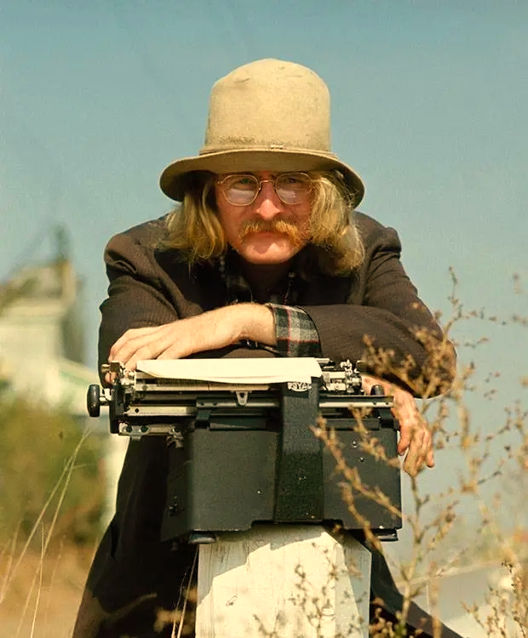

Although he’s primarily remembered now as a novelist, Richard Brautigan’s poetry was a force to be reckoned with for a decade or two. Robert Novak wrote of him in The Dictionary of Literary Biography that he was “commonly seen as the bridge between the Beat Movement of the 1950s and the youth revolution of the 1960s.” Critics at the time called him everything from “a visionary and enthusiast” to “a talented hick.”

The Pill Versus the Springhill Mine Disaster

When you take your pill
it's like a mine disaster.
I think of all the people lost inside of you.

The Day They Busted the Grateful Dead

The day they busted the Grateful Dead
rain stormed against San Francisco
like hot swampy scissors cutting Justice
into the evil clothes that alligators wear.

The day they busted the Grateful Dead
was like a flight of winged alligators
carefully measuring marble with black rubber telescopes.

The day they busted the Grateful Dead
turned like the wet breath of alligators
blowing up balloons the size of the Hall of Justice.

Automatic Anthole

Driven by hunger, I had another
forced bachelor dinner tonight.
I had a lot of trouble making
up my mind whether to eat Chinese
food or have a hamburger. God,
I hate eating dinner alone. It's like being dead.

At the California Institute of Technology

I don’t care how God-damn smart
these guys are: I’m bored.

It’s been raining like hell all day long
and there’s nothing to do.

Note:
Written January 24, 1967 while poet-in-residence at the California Institute of Technology.

The Double-Bed Dream Gallows

Driving through
hot brushy country
in the late autumn,
I saw a hawk
crucified on a
barbed-wire fence.

I guess as a kind
of advertisement
to other hawks,
saying from the pages
of a leading women’s
magazine,

“She’s beautiful,
but burn all the maps
to your body.
I’m not here
of my own choosing.”

I Feel Horrible. She Doesn’t

I feel horrible. She doesn’t
love me and I wander around
the house like a sewing machine
that’s just finished sewing
a turd to a garbage can lid.

To England

There are no postage stamps that send letters
back to England three centuries ago,
no postage stamps that make letters
travel back until the grave hasn't been dug yet,
and John Donne stands looking out the window,
it is just beginning to rain this April morning,
and the birds are falling into the trees
like chess pieces into an unplayed game,
and John Donne sees the postman coming up the street,
the postman walks very carefully because his cane
is made of glass.

Horse Race

July 19, a dog has been run over by an airplane,
an act that brings into this world the energy
that transforms vultures into beautiful black race horses.

Yes, the horses are waiting at the starting gate.
Now the sound of the gun and this fantastic race begins.
The horses are circling the track.

My Nose Is Growing Old

Yup.
A long lazy September look
in the mirror
say it's true:

I'm 31
and my nose is growing old.

It starts about ½ an inch
below the bridge
and strolls geriatrically down
for another inch or so: stopping.

Fortunately, the rest
of the nose is comparatively young.

I wonder if girls
will want me with an old nose.

I can hear them now
the heartless bitches!

"He's cute
but his nose
is old."

Comets

There are comets
that flash through
our mouths wearing
the grace
of oceans and galaxies.

God knows,
we try to do the best
we can.

There are comets
connected to chemicals
that telescope
down our tongues
to burn out against
the air.

I know
we do.

There are comets
that laugh at us
from behind our teeth
wearing the clothes
of fish and birds.

We try.

The Castle of the Cormorants

Hamlet with
a cormorant
under his arm
married Ophelia.
She was still
wet from drowning.
She looked like
a white flower
that had been
left in the
rain too long.
I love you,
said Ophelia,
and I love
that dark
bird you
hold in
your arms.

Big Sur
February 1958

The Postman

The smell

of vegetables

on a cold day

performs faithfully an act of reality
like a knight in search of the holy grail
or a postman on a rural route looking
for a farm that isn't there.

Carrots, peppers and berries.

Nerval, Baudelaire and Rimbaud.

I Cannot Answer You Tonight in Small Portions

I cannot answer you tonight in small portions.
Torn apart by stormy love's gate, I float
like a phantom facedown in a well where
the cold dark water reflects vague half-built stars
and trades all our affection, touching, sleeping
together for tribunal distance standing like
a drowned train just beyond a pile of Eskimo skeletons.

The Garlic Meat Lady from

We're cooking dinner tonight.
I'm making a kind of Stonehenge stroganoff.
Marcia is helping me. You
already know the legend of her beauty.
I've asked her to rub garlic
on the meat. She takes
each piece of meat like a lover
and rubs it gently with garlic.
I've never seen anything like this before. Every orifice
of the meat is explored, caressed relentlessly with garlic.
There is a passion here that would
drive a deaf saint to learn
the violin and play Beethoven at Stonehenge.

In a Café

I watched a man in a cafe fold a slice of bread as if he were folding a birth certificate or looking at the photograph of a dead lover.

You may scoff at the comparison, but Brautigan’s prose is as poetic as Woolf’s. He’s not as lyrical, but he’s certainly more inventive and imaginative. Here are two short excerpts from his most popular novels, Trout Fishing in America and In Watermelon Sugar.

from Trout Fishing in America

KNOCK ON WOOD (PART ONE)

As a child when did I first hear about trout fishing in America? From whom? I guess it was a stepfather of mine.

Summer of 1942.

The old drunk told me about trout fishing. When he could talk, he had a way of describing trout as if they were a precious and intelligent metal.

Silver is not a good adjective to describe what I felt when he told me about trout fishing.

I'd like to get it right.

Maybe trout steel. Steel made from trout. The clear snow-filled river acting as foundry and heat.

Imagine Pittsburgh.

A steel that comes from trout, used to make buildings, trains and tunnels.

The Andrew Carnegie of Trout!

The Reply of Trout Fishing in America:

I remember with particular amusement, people with three-cornered hats fishing in the dawn.

from In Watermelon Sugar

Book One

IN WATERMELON SUGAR the deeds were done and done again as my life is done in watermelon sugar. I'll tell you about it because I am here and you are distant.

Wherever you are, we must do the best we can. It is so far to travel, and we have nothing here to travel, except watermelon sugar. I hope this works out.

I live in a shack near iDEATH. I can see iDEATH out the window. It is beautiful. I can also see it with my eyes closed and touch it. Right now it is cold and turns like something in the hand of a child. I do not know what that thing could be.

There is a delicate balance in iDEATH. It suits us.

The shack is small but pleasing and comfortable as my life and made from pine, watermelon sugar and stones as just about everything here is.

Our lives we have carefully constructed from watermelon sugar and then travelled to the length of our dreams, along roads lined with pines and stones.

I have a bed, a chair, a table and a large chest that I keep my things in. I have a lantern that burns watermelontrout oil at night.

That is something else. I'll tell you about it later. I have a gentle life.

I go to the window and look out again. The sun is shining at the long edge of a cloud. It is Tuesday and the sun is golden.

I can see piney woods and the rivers that flow from those piney woods. The rivers are cold and clear and there are trout in the rivers.

Some of the rivers are only a few inches wide.

I know a river that is half-an-inch wide. I know because I measured it and sat beside it for a whole day. It started raining in the middle of the afternoon. We call everything a river here. We're that kind of people.

I can see fields of watermelons and the rivers that flow through them. There are many bridges in the piney woods and in the fields of watermelons. There is a bridge in front of this shack.

Some of the bridges are made of wood, old and stained silver like rain, and some of the bridges are made of stone gathered from a great distance and built in the order of that distance, and some of the bridges are made of watermelon sugar. I like those bridges best.

We make a great many things out of watermelon sugar here—I'll tell you about it—including this book being written near iDEATH.

All this will be gone into, travelled in watermelon sugar.

