DEREK WALCOTT

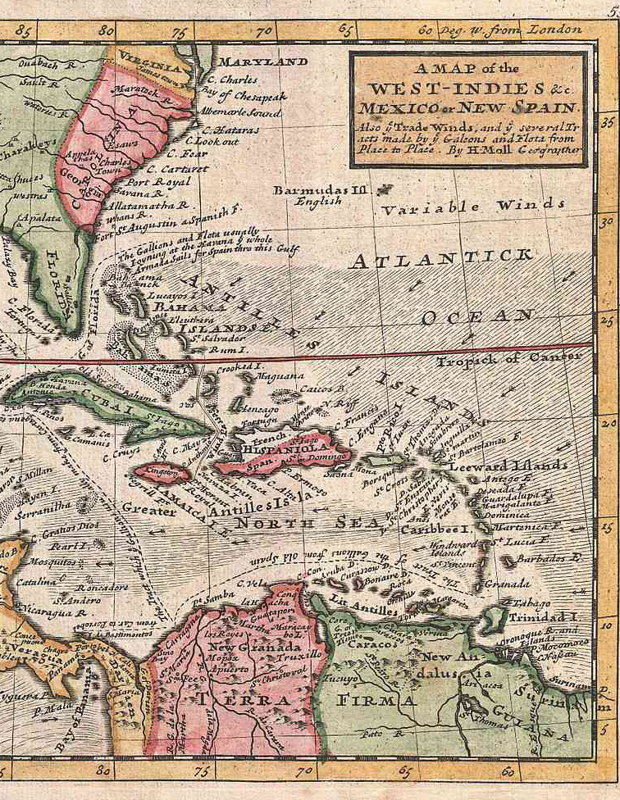
Selected Poetry

As John to Patmos

As John to Patmos, among the rocks and the blue, live air, hounded
His heart to peace, as here surrounded
By the strewn-silver on waves, the wood’s crude hair, the rounded
Breasts of the milky bays, palms flocks, the green and dead

Leaves, the sun’s brass coin on my cheek, where
Canoes brace the sun’s strength, as John, in that bleak air,
So am I welcomed richer by these blue ‘scapes, Greek there,
So I shall voyage no more from home; may I speak here.

This island is heaven – away from the dustblown blood of cities;
See the curve of bay, watch the straggling flower, pretty is
The wing’d sound of trees, the sparse-powdered sky, when lit is
The night. For beauty has surrounded
Its black children, and freed them of homeless ditties.

As John to Patmos, in each love-leaping air,
O slave, soldier, worker under red trees sleeping, hear
What I swear now, as John did:
To praise lovelong, the living and the brown dead.

Ruins of a Great House

though our longest sun sets at right declensions and makes but winter arches, it cannot be long before we lie down in darkness, and have our light in ashes...
Browne, Urn Burial

Stones only, the disjecta membra of this Great House,
Whose moth-like girls are mixed with candledust,
Remain to file the lizard's dragonish claws.
The mouths of those gate cherubs shriek with stain;
Axle and coach wheel silted under the muck
Of cattle droppings.
Three crows flap for the trees
And settle, creaking the eucalyptus boughs.
A smell of dead limes quickens in the nose
The leprosy of empire.
'Farewell, green fields,
Farewell, ye happy groves!'

Marble like Greece, like Faulkner's South in stone,
Deciduous beauty prospered and is gone,
But where the lawn breaks in a rash of trees
A spade below dead leaves will ring the bone
Of some dead animal or human thing
Fallen from evil days, from evil times.

It seems that the original crops were limes
Grown in the silt that clogs the river's skirt;
The imperious rakes are gone, their bright girls gone,
The river flows, obliterating hurt.
I climbed a wall with the grille ironwork
Of exiled craftsmen protecting that great house
From guilt, perhaps, but not from the worm's rent
Nor from the padded cavalry of the mouse.
And when a wind shook in the limes I heard
What Kipling heard, the death of a great empire, the abuse
Of ignorance by Bible and by sword.

A green lawn, broken by low walls of stone,
Dipped to the rivulet, and pacing, I thought next
Of men like Hawkins, Walter Raleigh, Drake,
Ancestral murderers and poets, more perplexed
In memory now by every ulcerous crime.
The world's green age then was a rotting lime

Whose stench became the charnel galleon's text.
The rot remains with us, the men are gone.
But, as dead ash is lifted in a wind
That fans the blackening ember of the mind,
My eyes burned from the ashen prose of Donne.

Ablaze with rage I thought,
Some slave is rotting in this manorial lake,
But still the coal of my compassion fought
That Albion too was once
A colony like ours, 'part of the continent, piece of the main',
Nook-shotten, rook o'erblown, deranged
By foaming channels and the vain expense
Of bitter faction.
All in compassion ends
So differently from what the heart arranged:
'as well as if a manor of thy friend's...'

The Almond Trees

There's nothing here
this early;
cold sand
cold churning ocean, the Atlantic,
no visible history,

except this stand
of twisted, coppery, sea-almond trees
their shining postures surely
bent as metal, and one

foam-haired, salt-grizzled fishennan,
his mongrel growling, whirling on the stick
he pitches him; its spinning rays
'no visible history'
until their lengthened shapes amaze the sun.

By noon,
this further shore of Africa is strewn
with the forked limbs of girls toasting their flesh
in scarves, sunglasses, Pompeian bikinis,

brown daphnes, laurels, they'll all have
like their originals, their sacred grove,
this frieze
of twisted, coppery, sea-almond trees.

The fierce acetylene air
has singed
their writhing trunks with rust, the same
hues as a foundered, peeling barge.
It'll sear a pale skin copper with its flame.

The sand's white-hot ash underheel,
but their aged limbs have got their brazen sheen
from fire. Their bodies fiercely shine!
They're cured,
they endured their furnace.

Aged trees and oiled limbs share a common colour!

Welded in one flame,
huddling naked, stripped of their name,
for Greek or Roman tags, they were lashed
raw by wind, washed
out with salt and fire-dried,
bitterly nourished where their branches died,

their leaves' broad dialect a coarse,
enduring sound
they shared together.

Not as some running hamadryad's cries
rooted, broke slowly into leaf
her nipples peaking to smooth, wooden boles

Their grief
howls seaward through charred, ravaged holes.
One sunburnt body now acknowledges
that past and its own metamorphosis
as, moving from the sun, she kneels to spread
her wrap within the bent arms of this grove
that grieves in silence, like parental love.

The Sea Is History

Where are your monuments, your battles, martyrs?
Where is your tribal memory? Sirs,
in that grey vault. The sea. The sea
has locked them up. The sea is History.

First, there was the heaving oil,
heavy as chaos;
then, like a light at the end of a tunnel,

the lantern of a caravel,
and that was Genesis.
Then there were the packed cries,
the shit, the moaning:

Exodus.
Bone soldered by coral to bone,
mosaics
mantled by the benediction of the shark’s shadow,

that was the Ark of the Covenant.
Then came from the plucked wires
of sunlight on the sea floor

the plangent harps of the Babylonian bondage,
as the white cowries clustered like manacles
on the drowned women,

and those were the ivory bracelets
of the Song of Solomon,
but the ocean kept turning blank pages

looking for History.
Then came the men with eyes heavy as anchors
who sank without tombs,

brigands who barbecued cattle,
leaving their charred ribs like palm leaves on the shore,
then the foaming, rabid maw

of the tidal wave swallowing Port Royal,
and that was Jonah,
but where is your Renaissance?

Sir, it is locked in them sea-sands
out there past the reef’s moiling shelf,
where the men-o’-war floated down;

strop on these goggles, I’ll guide you there myself.
It’s all subtle and submarine,
through colonnades of coral,

past the gothic windows of sea-fans
to where the crusty grouper, onyx-eyed,
blinks, weighted by its jewels, like a bald queen;

and these groined caves with barnacles
pitted like stone
are our cathedrals,

and the furnace before the hurricanes:
Gomorrah. Bones ground by windmills
into marl and cornmeal,

and that was Lamentations—
that was just Lamentations,
it was not History;

then came, like scum on the river’s drying lip,
the brown reeds of villages
mantling and congealing into towns,

and at evening, the midges’ choirs,
and above them, the spires
lancing the side of God

as His son set, and that was the New Testament.

Then came the white sisters clapping
to the waves’ progress,
and that was Emancipation—

jubilation, O jubilation—
vanishing swiftly
as the sea’s lace dries in the sun,

but that was not History,
that was only faith,
and then each rock broke into its own nation;

then came the synod of flies,
then came the secretarial heron,
then came the bullfrog bellowing for a vote,

fireflies with bright ideas
and bats like jetting ambassadors
and the mantis, like khaki police,

and the furred caterpillars of judges
examining each case closely,
and then in the dark ears of ferns

and in the salt chuckle of rocks
with their sea pools, there was the sound
like a rumour without any echo

of History, really beginning.

A City’s Death By Fire

After that hot gospeller has levelled all but the churched sky,
I wrote the tale by tallow of a city's death by fire;
Under a candle's eye, that smoked in tears, I
Wanted to tell, in more than wax, of faiths that were snapped like wire.
All day I walked abroad among the rubbled tales,
Shocked at each wall that stood on the street like a liar;
Loud was the bird-rocked sky, and all the clouds were bales
Torn open by looting, and white, in spite of the fire.
By the smoking sea, where Christ walked, I asked, why
Should a man wax tears, when his wooden world fails?
In town, leaves were paper, but the hills were a flock of faiths;
To a boy who walked all day, each leaf was a green breath
Rebuilding a love I thought was dead as nails,
Blessing the death and the baptism by fire.

A Far Cry From Africa

A wind is ruffling the tawny pelt
Of Africa, Kikuyu, quick as flies,
Batten upon the bloodstreams of the veldt.
Corpses are scattered through a paradise.
Only the worm, colonel of carrion, cries:
'Waste no compassion on these separate dead!'
Statistics justify and scholars seize
The salients of colonial policy.
What is that to the white child hacked in bed?
To savages, expendable as Jews?

Threshed out by beaters, the long rushes break
In a white dust of ibises whose cries
Have wheeled since civilizations dawn
From the parched river or beast-teeming plain.
The violence of beast on beast is read
As natural law, but upright man
Seeks his divinity by inflicting pain.
Delirious as these worried beasts, his wars
Dance to the tightened carcass of a drum,
While he calls courage still that native dread
Of the white peace contracted by the dead.

Again brutish necessity wipes its hands
Upon the napkin of a dirty cause, again
A waste of our compassion, as with Spain,
The gorilla wrestles with the superman.
I who am poisoned with the blood of both,
Where shall I turn, divided to the vein?
I who have cursed
The drunken officer of British rule, how choose
Between this Africa and the English tongue I love?
Betray them both, or give back what they give?
How can I face such slaughter and be cool?
How can I turn from Africa and live?

Map of the New World

I Archipelagoes

At the end of this sentence, rain will begin.
At the rain's edge, a sail.

Slowly the sail will lose sight of islands;
into a mist will go the belief in harbours
of an entire race.

The ten-years war is finished.
Helen's hair, a grey cloud.
Troy, a white ashpit
by the drizzling sea.

The drizzle tightens like the strings of a harp.
A man with clouded eyes picks up the rain
and plucks the first line of the Odyssey.

Parang

Man, I suck me tooth when I hear
How dem croptime fiddlers lie,
And de wailing, kiss-me-arse flutes
That bring water to me eye!
Oh, when I t'ink how from young
I wasted time at de fetes,
I could bawl in a red-eyed rage
For desire turned to regret,
Not knowing the truth that I sang
At parang and la commette.
Boy, every damned tune them tune
Of love that go last forever
Is the wax and the wane of the moon
Since Adam catch body-fever.

I old, so the young crop won't
Have these claws to reap their waist,
But I know 'do more' from 'don't'
Since the grave cry out 'Make haste!'
This banjo world have one string
And all man does dance to that tune:
That love is a place in the bush
With music grieving from far,
As you look past her shoulder and see
Like her one tear afterwards

The falling of a fixed star.
Yound men does bring love to disgrace
With remorseful, regretful words,
When flesh upon flesh was the tune
Since the first cloud raise up to disclose
The breast of the naked moon.

