Eavan Boland

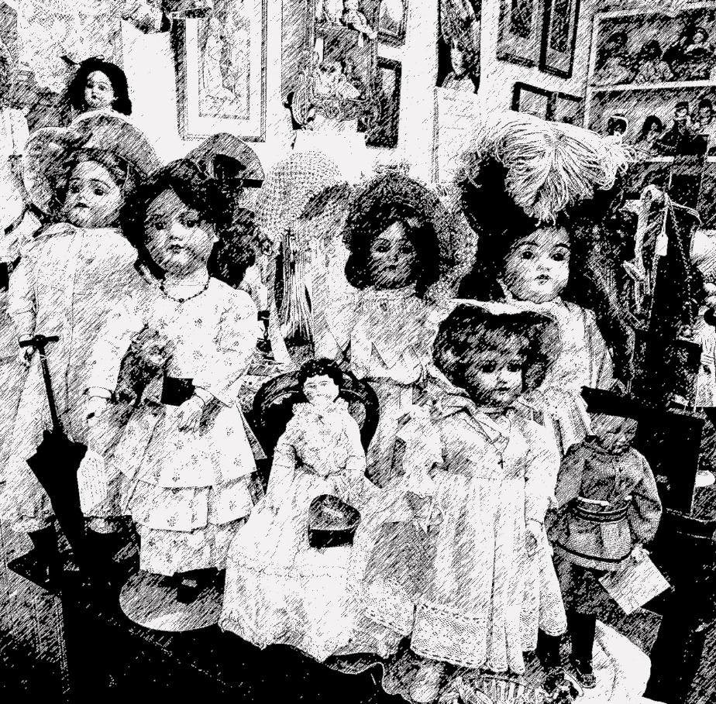

Selected Poems

Ode to Suburbia

Six o'clock: the kitchen bulbs which blister
Your dark, your housewives starting to nose
Out each other's day, the claustrophobia
Of your back gardens varicose
With shrubs, make an ugly sister
Of you suburbia.

How long ago did the glass in your windows subtly
Silver into mirrors which again
And again show the same woman
Shriek at a child? Which multiply
A dish, a brush, ash,
The gape of a fish.

In the kitchen, the gape of a child in the cot?
You swelled so that when you tried
The silver slipper on your foot
It pinched your instep and the common
Hurt which touched you made
You human.

No creature of the streets will feel the touch
Of a wand turning the wet sinews
Of fruit suddenly to a coach,
While this rat without leather reins
Or a whip or britches continues
Sliming your drains.

No magic here. Yet you encroach until
The shy countryside, fooled
By your plainness falls, then rises
From your bed changed, schooled
Forever by your skill,
Your compromises.

Midnight and your metamorphosis
Is now complete, although the mind
Which spinstered you might still miss
Your mystery now, might still fail
To see your power defined
By this detail.

By this creature drowsing now in every house—
The same lion who tore stripes
Once off zebras. Who now sleeps,
Small beside the coals. And may,
On a red letter day,
Catch a mouse.

from The War Horse, 1975
Anorexic

Flesh is heretic.
My body is a witch.
I am burning it.

Yes I am torching
her curves and paps and wiles.
They scorch in my self denials.

How she meshed my head
in the half-truths
of her fevers

till I renounced
milk and honey
and the taste of lunch.

I vomited
her hungers.
Now the bitch is burning.

I am starved and curveless.
I am skin and bone.
She has learned her lesson.

Thin as a rib
I turn in sleep.
My dreams probe

a claustrophobia
a sensuous enclosure.
How warm it was and wide

once by a warm drum,
once by the song of his breath
and in his sleeping side.

Only a little more,
only a few more days
sinless, foodless,

I will slip
back into him again
as if I had never been away.

Caged so
I will grow
angular and holy

past pain,
keeping his heart
such company

as will make me forget
in a small space
the fall

into forked dark,
into python needs
heaving to hips and breasts
and lips and heat
and sweat and fat and greed.

from In Her Own Image, 1980
Night Feed

This is dawn
Believe me
This is your season, little daughter.
The moment daisies open,
the hour mercurial rainwater
Makes a mirror for sparrows.
It's time we drowned our sorrows.

I tiptoe in.
I lift you up
Wriggling
In your rosy, zipped sleeper.
Yes, this is the hour
For the early bird and me
When finder is keeper.

I crook the bottle.
How you suckle!
This is the best I can be,
Housewife
To this nursery
Where you hold on,
Dear life.

A silt of milk.
The last suck
And now your eyes are open,
Birth-coloured and offended.
Earth wakes.
You go back to sleep.
The feed is ended.

Worms turn.
Stars go in.
Even the moon is losing face.
Poplars stilt for dawn
And we begin
The long fall from grace.
I tuck you in.

from Night Feed, 1982

The Journey
for Elizabeth Ryle

Immediately cries were heard. These were the loud wailing of infant souls weeping at the very entrance-way; never had they had their share of life’s sweetness for the dark day had stolen them from their mothers’ breasts and plunged them to a death before their time.
—Virgil, The Aeneid, Book VI

And then the dark fell and ‘there has never’
I said ‘been a poem to an antibiotic:
never a word to compare with the odes on
the flower of the raw sloe for fever

‘or the devious Africa-seeking tern
or the protein treasures of the sea-bed.
Depend on it, somewhere a poet is wasting
his sweet uncluttered metres on the obvious

‘emblem instead of the real thing.
Instead of sulpha we shall have hyssop dipped
in the wild blood of the unblemished lamb,
so every day the language gets less

‘for the task and we are less with the language.’
I finished speaking and the anger faded
and dark fell and the book beside me
lay open at the page Aphrodite

comforts Sappho in her love’s duress.
The poplars shifted their music in the garden,
a child startled in a dream,
my room was a mess—

the usual hardcovers, half-finished cups,
clothes piled up on an old chair—
and I was listening out but in my head was
a loosening and sweetening heaviness,

not sleep, but nearly sleep, not dreaming really
but as ready to believe and still
unfevered, calm and unsurprised
when she came and stood beside me

and I would have known her anywhere
and I would have gone with her anywhere
and she came wordlessly
and without a word I went with her

down down down without so much as
ever touching down but always, always
with a sense of mulch beneath us,
the way of stairs winding down to a river

and as we went on the light went on
failing and I looked sideways to be certain
it was she, misshapen, musical—
Sappho—the scholiast’s nightingale

and down we went, again down
until we came to a sudden rest
beside a river in what seemed to be
an oppressive suburb of the dawn.

My eyes got slowly used to the bad light.
At first I saw shadows, only shadows.
Then I could make out women and children
and, in the way they were, the grace of love.

‘Cholera, typhus, croup, diptheria’
she said, ‘in those days they racketed
in every backstreet and alley of old Europe.
Behold the children of the plague.’

Then to my horror I could see to each
nipple some had clipped a limpet shape—
suckling darknesses—while others had their arms
weighed down, making terrible piet? s.

She took my sleeve and said to me, ‘be careful.
Do not define these women by their work:
not as washerwomen trussed in dust and sweating,
muscling water into linen by the river’s edge

‘nor as court ladies brailled in silk
on wool and woven with an ivory unicorn
and hung, nor as laundresses tossing cotton,
brisking daylight with lavender and gossip.

‘But these are women who went out like you
when dusk became a dark sweet with leaves,
recovering the day, stooping, picking up
teddy bears and rag dolls and tricycles and buckets—

‘love’s archaeology—and they too like you
stood boot deep in flowers once in summer
or saw winter come in with a single magpie
in a caul of haws, a solo harlequin.’

I stood fixed. I could not reach or speak to them.
Between us was the melancholy river,
the dream water, the narcotic crossing
and they had passed over it, its cold persuasions.

I whispered, ‘let me be
let me at least be their witness,’ but she said
‘what you have seen is beyond speech,
beyond song, only not beyond love;

‘remember it, you will remember it’
and I heard her say but she was fading fast
as we emerged under the stars of heaven,
‘there are not many of us; you are dear

‘and stand beside me as my own daughter.
I have brought you here so you will know forever
the silences in which are our beginnings,
in which we have an origin like water,’

and the wind shifted and the window clasp
opened, banged and I woke up to find
the poetry books stacked higgledy piggledy,
my skirt spread out where I had laid it—

nothing was changed; nothing was more clear
but it was wet and the year was late.
The rain was grief in arrears; my children
slept the last dark out safely and I wept.

from The Journey, 1987

The Dolls Museum in Dublin

The wounds are terrible. The paint is old.
The cracks along the lips and on the cheeks
cannot be fixed. The cotton lawn is soiled.
The arms are ivory dissolved to wax.

Recall the Quadrille. Hum the waltz.
Promenade on the yacht-club terraces.
Put back the lamps in their copper holders,
the carriage wheels on the cobbled quays.

And recreate Easter in Dublin.
Booted officers. Their mistresses.
Sunlight criss-crossing College Green.
Steam hissing from the flanks of horses.

Here they are. Cradled and cleaned,
held close in the arms of their owners.
Their cold hands clasped by warm hands,
their faces memorized like perfect manners.

The altars are mannerly with linen.
The lilies are whiter than surplices.
The candles are burning and warning:
Rejoice, they whisper. After sacrifice.

Horse-chestnuts hold up their candles.
The Green is vivid with parasols.
Sunlight is pastel and windless.
The bar of the Shelbourne is full.

Laughter and gossip on the terraces.
Rumour and alarm at the barracks.
The Empire is summoning its officers.
The carriages are turning: they are turning back.

Past children walk with governesses,
Looking down, cossetting their dolls,
then looking up as the carriage passes,
the shadow chilling them. Twilight falls.

It is twilight in the dolls' museum. Shadows
remain on the parchment-coloured waists,
are bruises on the stitched cotton clothes,
are hidden on the dimples on the wrists.

The eyes are wide. They cannot address
the helplessness which has lingered in
the airless peace of each glass case:
to have survived. To have been stronger than

a moment. To be the hostages ignorance
takes from time and ornament from destiny. Both.
To be the present of the past. To infer the difference
with a terrible stare. But not feel it. And not know it.

from In a Time of Violence, 1994
The Pomegranate

The only legend I have ever loved is
the story of a daughter lost in hell.
And found and rescued there.
Love and blackmail are the gist of it.
Ceres and Persephone the names.
And the best thing about the legend is
I can enter it anywhere. And have.
As a child in exile in
a city of fogs and strange consonants,
I read it first and at first I was
an exiled child in the crackling dusk of
the underworld, the stars blighted. Later
I walked out in a summer twilight
searching for my daughter at bed-time.
When she came running I was ready
to make any bargain to keep her.
I carried her back past whitebeams
and wasps and honey-scented buddleias.
But I was Ceres then and I knew
winter was in store for every leaf
on every tree on that road.
Was inescapable for each one we passed.
And for me.
It is winter
and the stars are hidden.
I climb the stairs and stand where I can see
my child asleep beside her teen magazines,
her can of Coke, her plate of uncut fruit.
The pomegranate! How did I forget it?
She could have come home and been safe
and ended the story and all
our heart-broken searching but she reached
out a hand and plucked a pomegranate.
She put out her hand and pulled down
the French sound for apple and
the noise of stone and the proof
that even in the place of death,
at the heart of legend, in the midst
of rocks full of unshed tears
ready to be diamonds by the time
the story was told, a child can be
hungry. I could warn her. There is still a chance.

The rain is cold. The road is flint-coloured.
The suburb has cars and cable television.
The veiled stars are above ground.
It is another world. But what else
can a mother give her daughter but such
beautiful rifts in time?
If I defer the grief I will diminish the gift.
The legend will be hers as well as mine.
She will enter it. As I have.
She will wake up. She will hold
the papery flushed skin in her hand.
And to her lips. I will say nothing.

from In a Time of Violence, 1994
In Which the Ancient History I Learn is Not My Own

The linen map
hung from the wall.
The linen was shiny
and cracked in places.
The cracks were darkened by grime.
It was fastened to the classroom wall with
a wooden batten on
a triangle of knotted cotton.

The colours
were faded out
so the red of Empire---
the stain of absolute possession---
the mark once made from Kashmir
to the coast-barns of the Kent
coast south of us was
underwater coral.

Ireland was far away
and farther away
every year.
I was nearly an English child.
I could list the English kings.
I could name the famous battles.
I was learning to recognize
God's grace in history.

And the waters
of the Irish sea,
their shallow weave
and cross-grained blue green
had drained away
to the pale gaze
of a doll's china eyes---
a stare without recognition or memory.

We have no oracles,
no rocks or olive trees,
no sacred path to the temple
and no priestesses.
The teacher's voice had a London accent.
This was London. 1952.
It was Ancient History Class.
She put the tip
of the wooden
pointer on the map.

She tapped over ridges and dried-
out rivers and cities buried in
the sea and sea-scapes which
had once been land.
And stopped.
Remember this, children.

The Roman Empire was
the greatest Empire
ever known---
until our time of course---
while the Delphic Oracle
was reckoned to be
the exact centre
of the earth.

Suddenly
I wanted
to stand in front of it.
I wanted to trace over
and over the weave of my own country.
To read out names
I was close to forgetting.
Wicklow. Kilruddery. Dublin.

To ask
where exactly
was my old house?
Its brass One and Seven.
Its flight of granite steps.
Its lilac tree whose scent
stayed under your fingernails
for days.

For days—
she was saying — even months,
the ancients travelled
to the Oracle.
They brought sheep and killed them.
They brought questions about tillage and war.
They rarely left with more
than an ambiguous answer.

from In a Time of Violence, 1994

That the Science of Cartography is Limited

—and not simply by the fact that this shading of
forest cannot show the fragrance of balsam,
the gloom of cypresses
is what I wish to prove.

When you and I were first in love we drove
to the borders of Connacht
and entered a wood there.

Look down you said: this was once a famine road.

I looked down at ivy and the scutch grass
rough-cast stone had
disappeared into as you told me
in the second winter of their ordeal, in

1847, when the crop had failed twice,
Relief Committees gave
the starving Irish such roads to build.

Where they died, there the road ended

and ends still and when I take down
the map of this island, it is never so
I can say here is
the masterful, the apt rendering of
the spherical as flat, nor
an ingenious design which persuades a curve
into a plane,
but to tell myself again that
the line which says woodland and cries hunger
and gives out among sweet pine and cypress,
and finds no horizon

will not be there.

Literary Review, Fall 2000

The Room in Which My First Child Slept

After a while I thought of it this way:
It was a town underneath a mountain
crowned by snow and every year a river
rushed through, enveloping the dusk
in a noise everyone knew signaled spring—
a small town, known for a kind of calico,
made there, strong and unglazed,
a makeshift of cotton in which the actual
unseparated husks still remained and
could be found if you looked behind
the coarse daisies and the red-billed bird
with swept-back wings always trying to
arrive safely on the inch or so of cotton it
might have occupied if anyone had offered it.
And if you ask me now what happened to it—
the town that is—the answer is of course
there was no town, it never actually
existed, and the calico, the glazed cotton
on which a bird never landed is not gone,
because it never was, never once, but then
how to explain that sometimes I can hear
the river in those first days of April, making
its way through the dusk, having learned
to speak the way I once spoke, saying
as if I didn't love you,
as if I wouldn't have died for you.

Poetry, October 2006

Quarantine

In the worst hour of the worst season
of the worst year of a whole people
a man set out from the workhouse with his wife.
He was walking – they were both waking – north.

She was sick with famine fever and could not keep up.
He lifted her and put her on his back.
He walked like that west and west and north.
Until at nightfall under freezing stars they arrived.

In the morning they were both found dead.
Of cold. Of hunger. Of the toxins of a whole history.
But her feet were held against his breastbone.
The last heat of his flesh was his last gift to her.

Let no love poem ever come to this threshold.
There is no place here for the inexact
praise of the easy graces and sensuality of the body.
There is only time for this merciless inventory:

Their death together in the winter of 1847.
Also what they suffered. How they lived.
And what there is between a man and woman.
And in which darkness it can best be proved.

from Collected Poems, 2008

